# Connecting to the vSphere Web Client using Citrix

**NOTE: Please call the Help Desk with any connection issues at 920-735-5644 (Summer Help Desk Hours: Monday-Friday 8-4:30p).**

1. Open a supported browser (Google Chrome preferred)
2. Log into Citrix using student credentials: <https://myapps.fvtc.edu/>

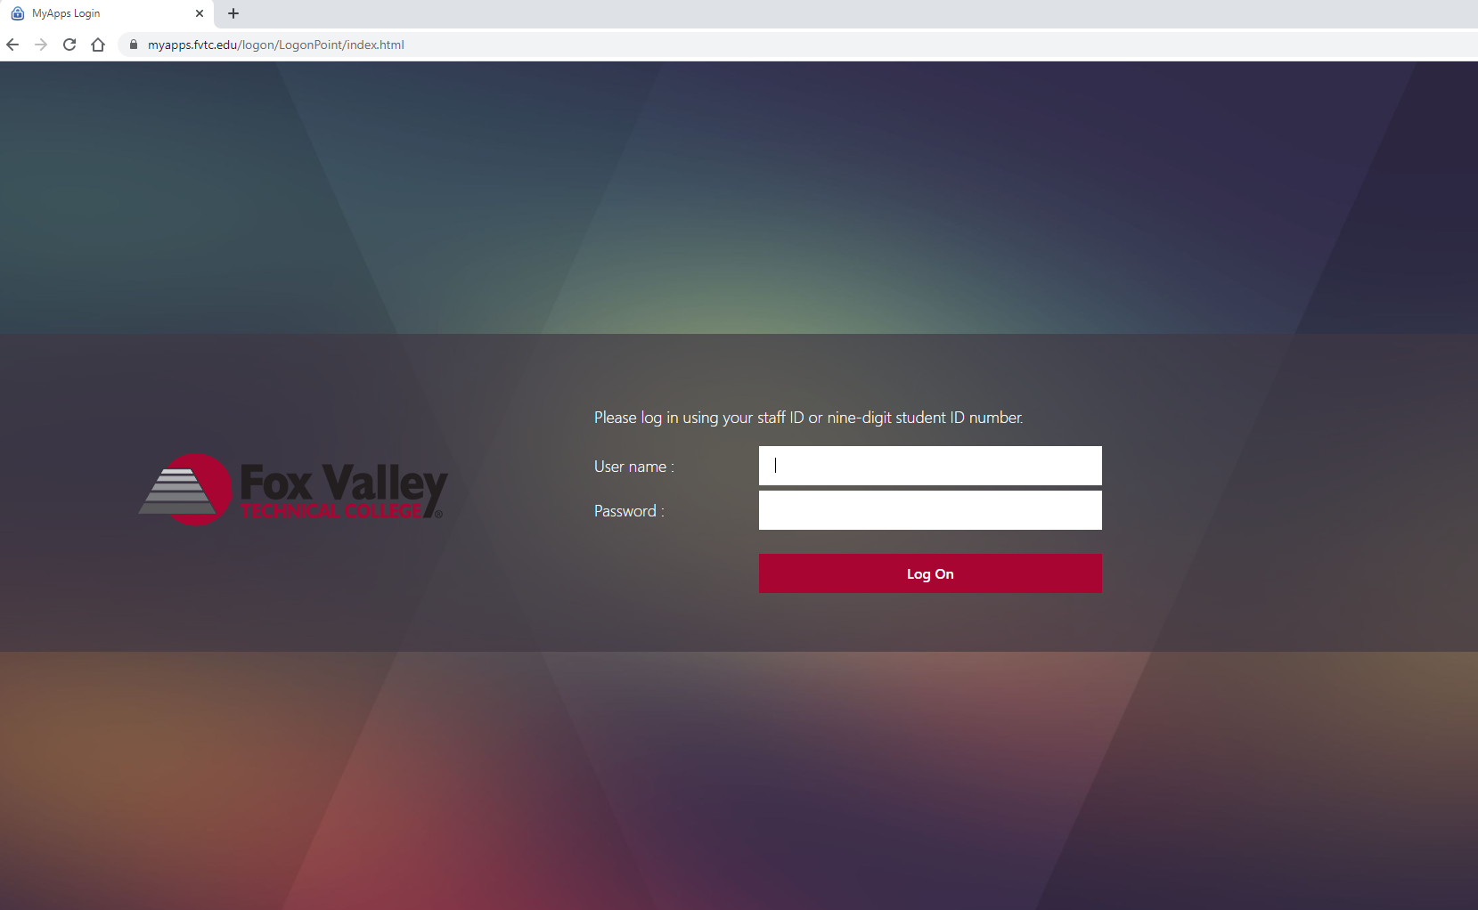

1. Click on the “Apps” tab at the top of the page.

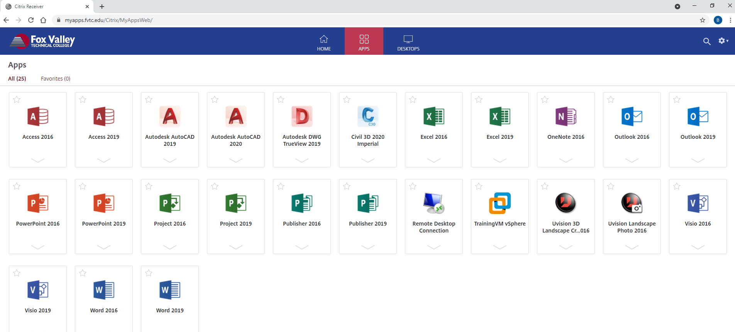

1. Click on the TrainingVM vSphere application.

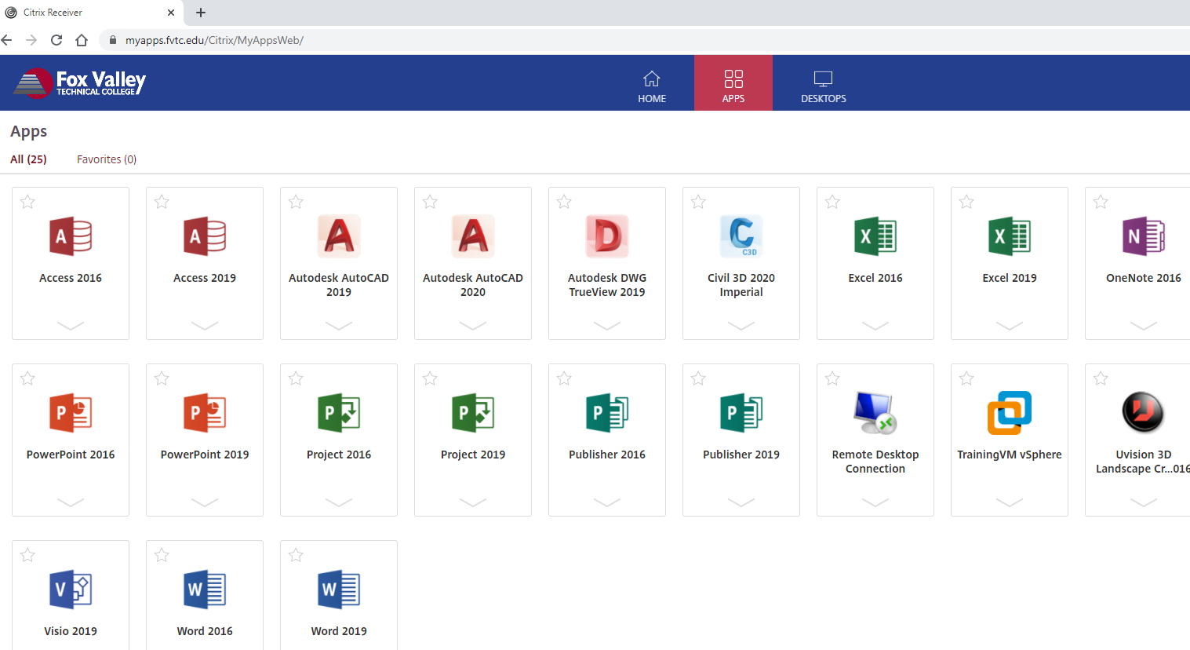

1. Enter your username (either username@fvtc.edu or fvtc\username format) and Password and click Login.

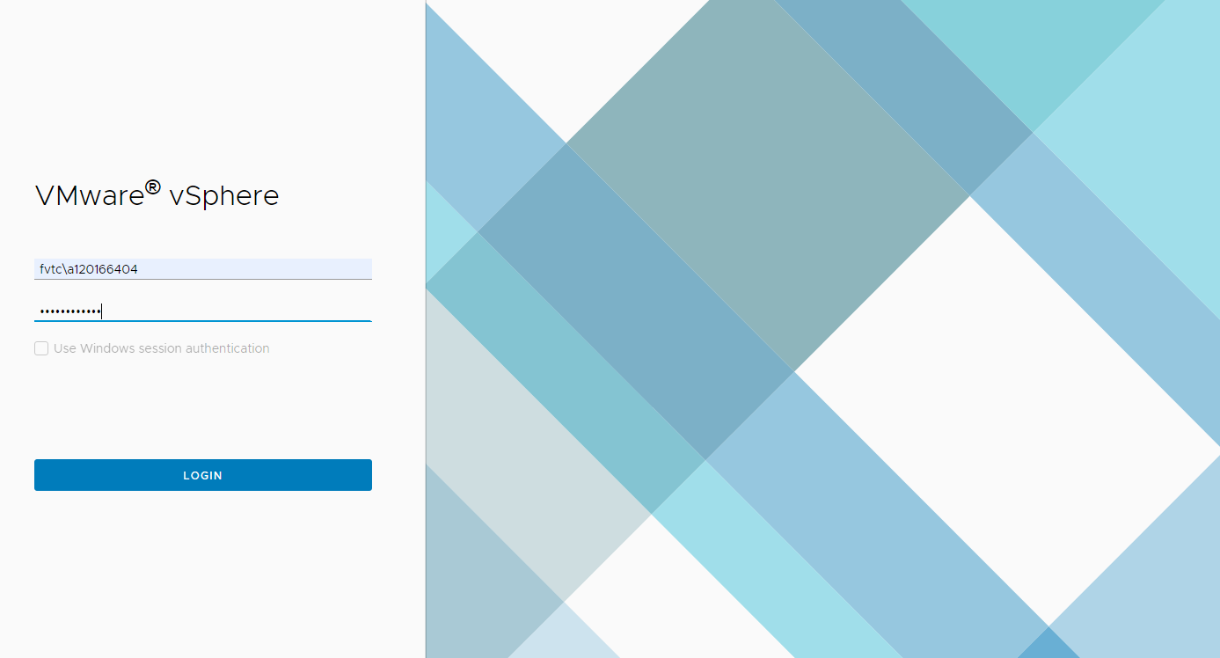

1. Click the second tab to view the VMs and Templates.

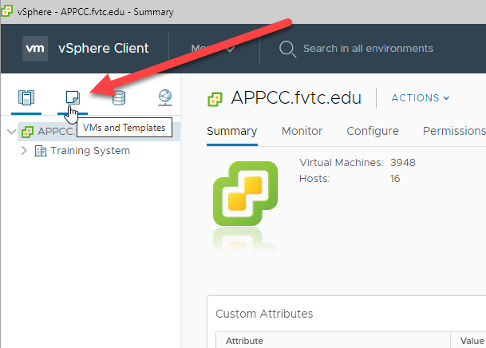

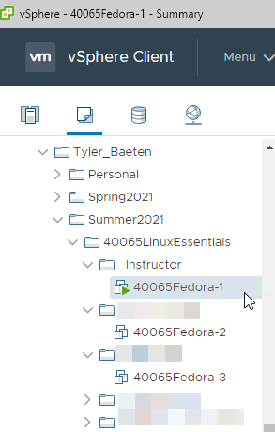

1. Expand the tree to see which VMs you have access to and click on the desired VM.
   1. Students will have a folder with their instructor’s name followed by a folder for the semester and their class name. Student VMs will be found inside a folder with their name.
2. Right click on a VM and select Power On to turn on the VM or right click and select Open Console to view the console of the VM.

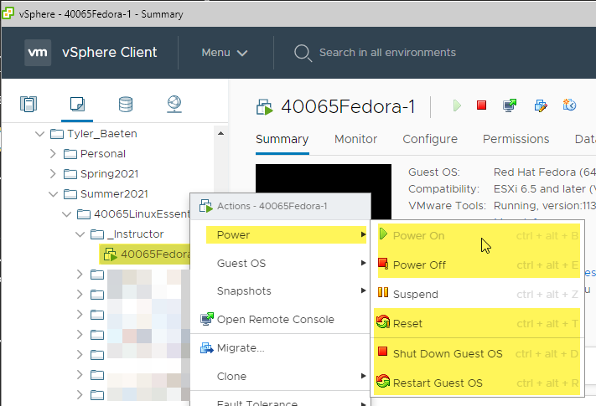

1. After clicking the desired VM, click on the Summary tab, and then click Launch Remote Console. This will create a popup where you will need to select ‘Open’ to open your VM in a separate window using the VMware Remote Console (VMRC) software.

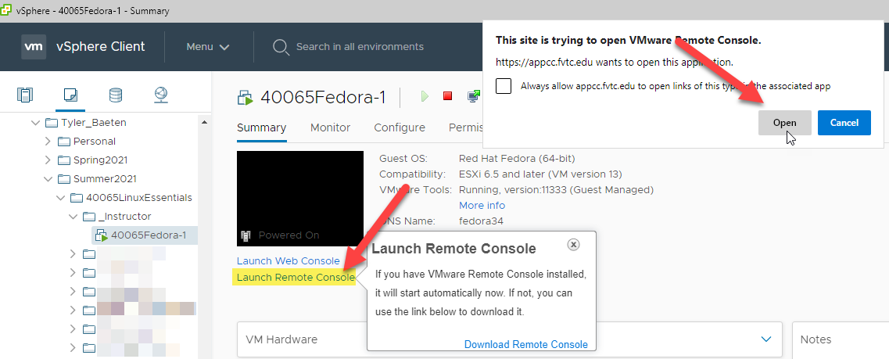

1. If you receive a certificate error, select to connect anyway.

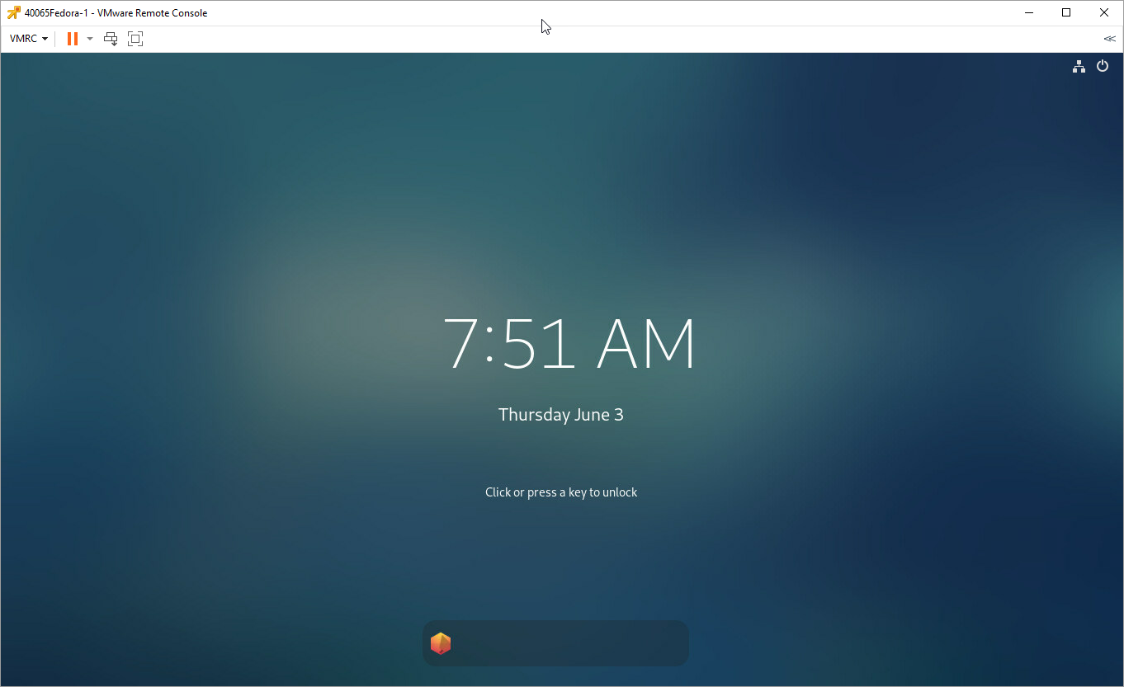

# Connecting to the vSphere Web Client (Least Preferred Method)

1. It is preferred to use the VMware Remote Console (VMRC) software and launch a remote console to interact with your virtual machines. Alternatively, you may use the web console as a backup method.
2. Upon selecting your VM and navigating to the summary tab you can select ‘Launch Web Console’ which will create a popup where you can select ‘OK’ to open your VM in a new web browser Window.

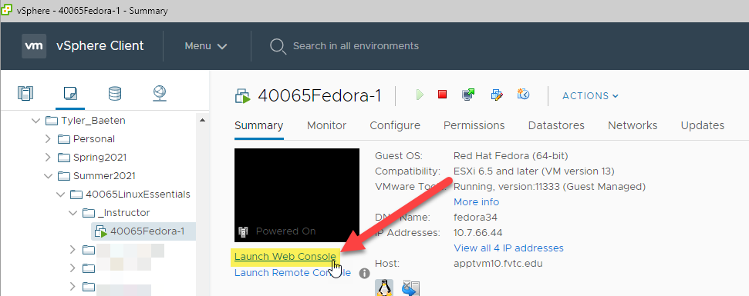

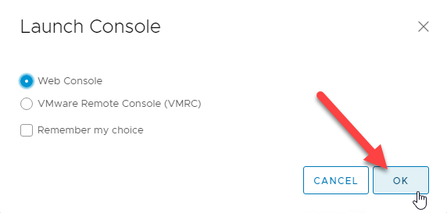

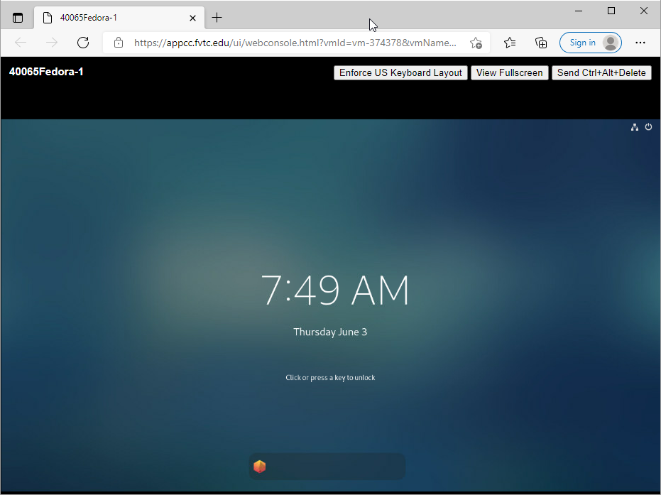

1. When completed, back at the vmware vSphere Web Client window, click the arrow next to your username and select Logout.